UHF Access Reader Software User Manual

Table of contents
1. Reader/Writer Description 2
1.1 Operating Environment 2
1.2 Reader Description 2
1.3 EPC -6 C Knowledge 2
1.3.1 Storage Area 2
1.3.2​Use cases for Q-value and Session 3
2. Parameter query settings 3
2.1 Connecting to the host computer 3
2.1.1 RS232 Connection 3
2.1.2 USB Connection 4
2.2 Software Settings 4
2.3 Verify parameters 5
2.4 Obtain all parameters 6
2.5 Parameter Settings 6
2.5.1 Output Power Setting 6
2.5.2 Operating Frequency Band Settings 7
2.5.3 Device Address 8
2.5.4 Baud Rate 9
2.5.5 Card Reader Parameter Settings 9
2.5.6 Default Parameters - Factory Reset 10
3. Answer mode reader / writer card 10
3.1 Answer Mode Card Reader Settings 10
3.2 Read the card by time 11
3.3 Read the card by number of times 12
4. Active Mode 13
5. Trigger Mode 14
6. Common Mistakes 15
6.1 Device cannot connect 15
6.2 Parameter out of bounds : 15
6.3 antenna is not connected . 16
6.4 The software automatically disconnects . 16
6.5 reader failed to open. 17

1. Reader/Writer Description

1.1 Operating Environment
This software supports the following operating systems: Windows 2000, Windows XP, Windows 7, Windows 8, Windows 10 and later.

1.2 Reader Description
①Supports answer mode, active mode, and trigger mode.
②Supports reading EPC, TID, and USER in various modes.
③ You can set the filtering time (a single label will only be output once within a specified time).
④ Supports interval time query, reducing power consumption.
⑤ Supports specifying the start address and length for output.
⑥ All parameters are integrated into a single instruction, making development easy.

1.3 EPC -6 C Knowledge
Bit : One binary digit is called 1 bit, which contains only " 0" and "1 ".
Byte : One byte is 8 bits. For example , 0 x 10 is one byte, in hexadecimal.
Word : Two bytes make up one word. In memory, all data is stored in units of words.

1.3.1 Storage Area
Logically, the tag memory is divided into four storage areas, each of which can consist of one or more memory words. These four storage areas are:
EPC Area (EPC): This area stores EPC numbers . EPC numbers start from the digit 2. All displayed EPCs are EPC numbers, which are readable and writable .
TID Area (TID): Stores an ID number set by the tag manufacturer. Currently, there are two types of ID numbers: 4 characters and 8 characters . It is readable but not writable.
User area: This area varies between manufacturers. NXP 's Ucode 7 tag does not have a user area. Alien 's H3 tag has 32 characters . It is readable and writable.
Password field: The first two characters are the kill password , and the last two characters are the access password . It is readable and writable.

All four storage areas can be write- locked . Write locking means that the area can never be written to or cannot be written to in an insecure state; read locking can only be set to read locking for the password area , meaning it cannot be read.

1.3.2​Use cases for Q-value and Session
1) Q value: divided into static Q value and dynamic Q value; MU912, MU914 and MU918 use dynamic Q value; MU910-M uses static Q value;
Use case : Generally, the value is selected based on the number of surrounding tags. For example, if there are 30 surrounding tags, then Q will be 5. The value range is 0~15, with a default of 4 .
2) Session: Includes two states, A and B. Different sessions have different characteristics. For example, after S0 leaves the sensing field range, its state will immediately change from B to A. Some devices support AUTO.
Use Cases: S0: Suitable for rapid identification scenarios, such as rapid assembly lines in intelligent transportation production automation, mainly used for single or small number of labels. S1: Used for scenarios with multiple labels in a certain batch, such as managing boxes of clothing or several small shelves. S2 and S3: Used for scenarios with a large number of labels, such as warehouse management.

2. Parameter query settings

2.1 Connecting to the host computer

2.1.1 RS232 Connection
1. After the module is powered on, the buzzer will sound for one second. If you do not hear the buzzer, you need to check if the power is on properly (the module has an LED power-on indicator ) .
2. Open the testing software UHF Access . In Reader V 1.4 , select the correct serial port number and click "Open".
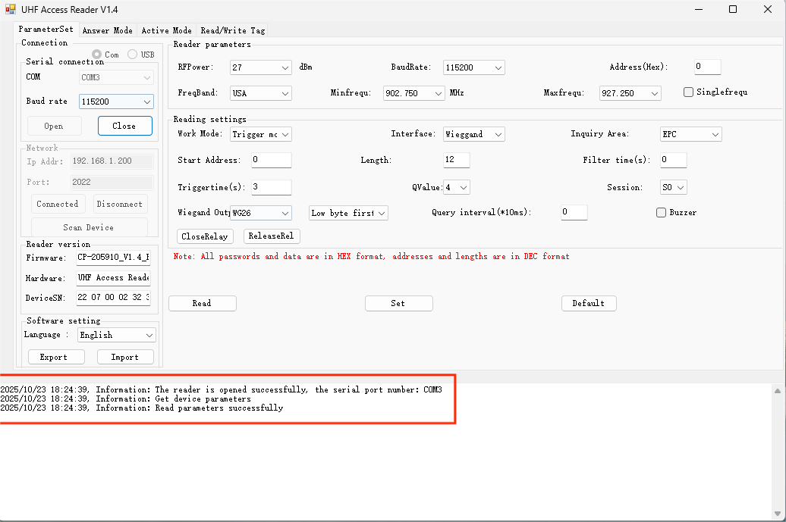

2.1.2 USB Connection
1. After the module is powered on, the buzzer will sound for one second. If you do not hear the buzzer, you need to check if the power is on properly (the module has an LED power-on indicator ) .
2. Open the testing software UHF Access . In Reader V 1.4 , click "Scan Devices" and check if the IP address of the scanned device is on the same network segment as your computer's IP address. If not, double-click the scanned IP address and change it to an IP address on the same network segment as your computer .

2.2 Software Settings
Click on the language selection, select the desired language, and then restart the testing software to display the testing software in the corresponding language. Importing language packs is also supported.
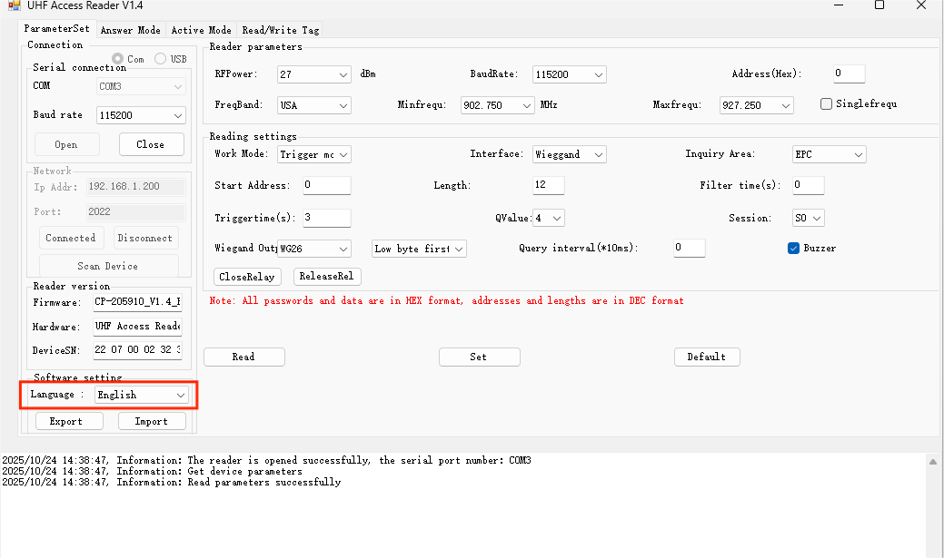

2.3 Verify parameters
After the software successfully connects to the device, various operations can be performed. Once connected, the software will automatically send commands to obtain parameters such as reader parameters, card settings, reader version, and software settings.
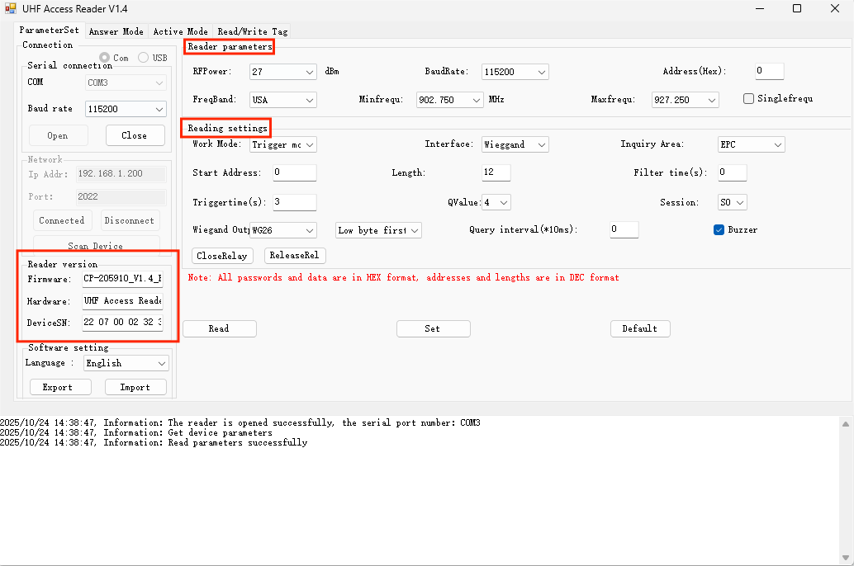

2.4 Obtain all parameters
To find out the current card reader parameters and card reading settings, click "Get All Parameters". The software will then return a successful response indicating that the current card reader parameters and card reading settings have been obtained.
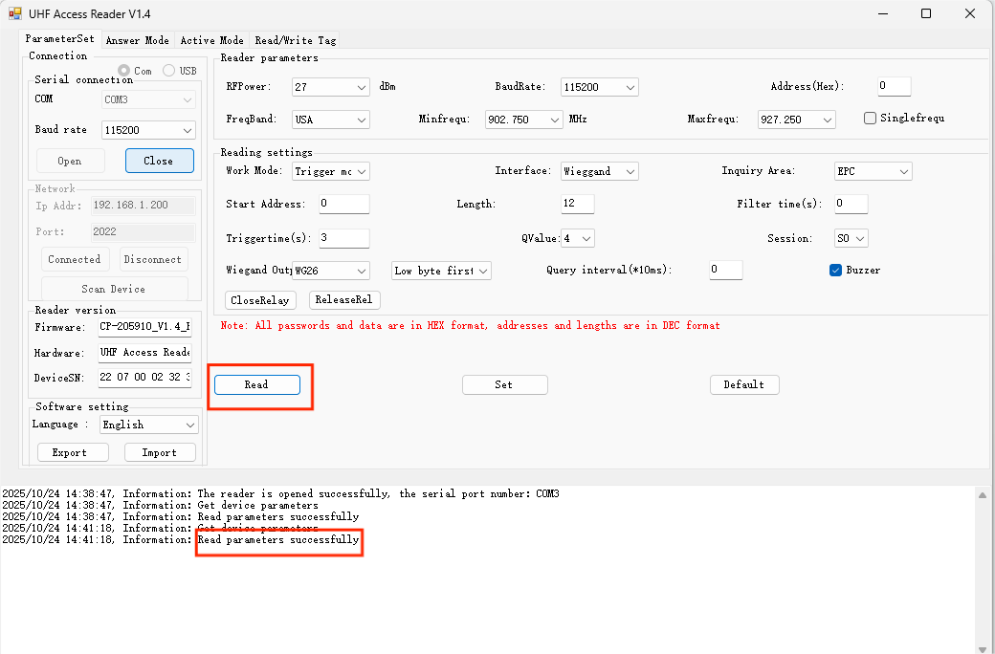

2.5 Parameter Settings

2.5.1 Output Power Setting
Click the power option, select the power value you want to set, and then click "Set All Parameters".
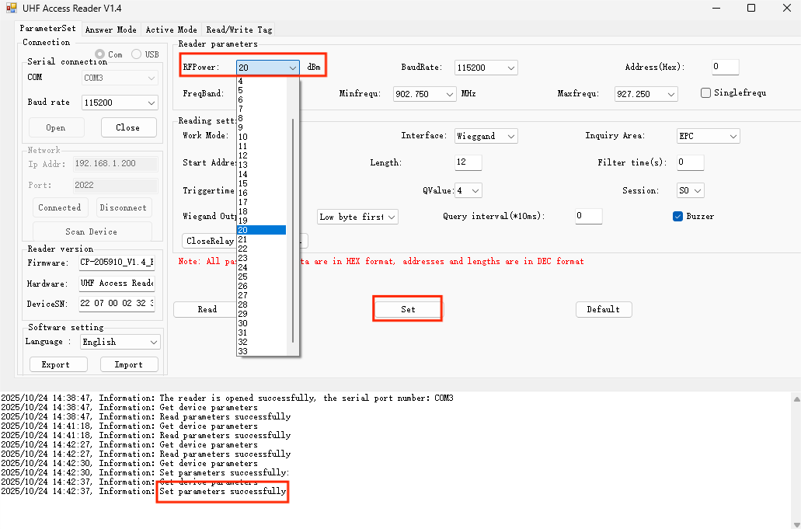

2.5.2 Operating Frequency Band Settings
(1) Click the operating frequency band option, select the operating frequency band you want to set, and then click "Set All Parameters";
(2) Set the "Starting Frequency Band" and "Ending Frequency Band". Click to select the starting frequency band and ending frequency band, then click to set all parameters. Note that the starting frequency band cannot be higher than the ending frequency band.
(3) Single Frequency Point: Clicking "Single Frequency Point" will automatically change the ending frequency band to the same frequency as the starting frequency band; then click "Set All Parameters".
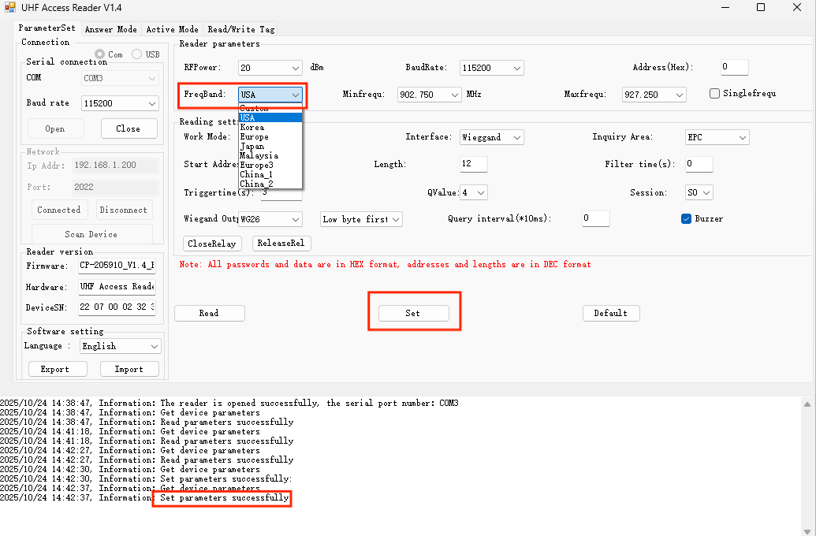

2.5.3 Device Address
Used to distinguish devices, the factory default value range is 0x00-0xFE , and 0xFF is the broadcast address; the device only responds to command frames with its own device address and broadcast address.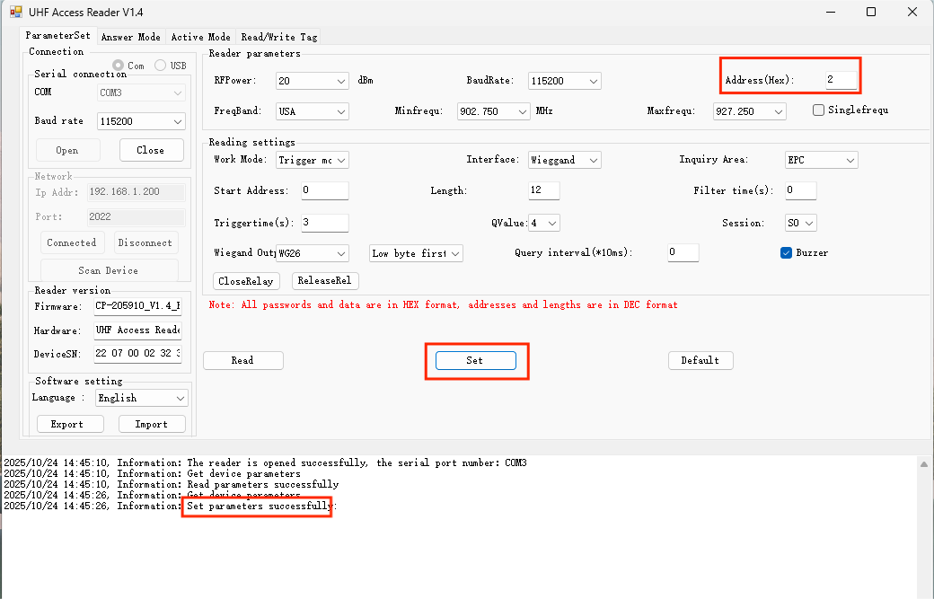

2.5.4 Baud Rate
The default baud rate is 115200. Click to select the baud rate and then set it.
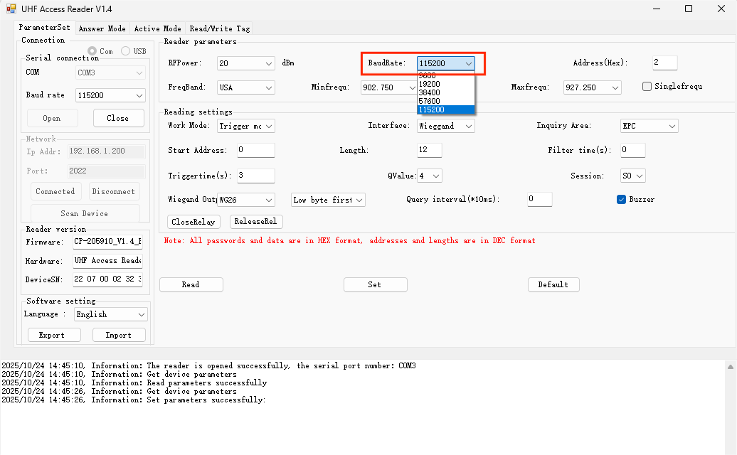

2.5.5 Card Reader Parameter Settings
- Working modes: There are three working modes to choose from: active mode, answer mode, and trigger mode;
- Communication interface: Default Wiegand output, supports RS232, USB, keyboard, CDC_COM and other output methods;
- Inquiry area (number): includes Reserve, EPC, TID, and User;
- Starting address (Byte): Sets the starting address of the output data. For example, if the data E2000020340F02081980B498 starts at address 4, then the output data becomes 340F02081980B498.
- Byte length: Sets the length of the output data;
- Filtering time (S): The filtering time is the interval between the reader reading the same electronic tag. The filtering time is invalid when there are multiple tags around the reader.
- Q value: Q value is 0-15;
- Session: Values range from S0 to S3; some devices support AUTO.
- Query interval (*10ms): The interval between the end of one poll and the start of the next poll for the reader/writer, which can control the speed of card reading;
- Buzzer Enable: Selecting to enable the buzzer will sound an audio prompt when the reader reads a card; selecting to disable the buzzer will not sound an audio prompt when the reader reads a card.
- Wiegand output : You can choose WG26 or WG34 output, or you can choose low byte first or high byte first output;
- Trigger time: The time it takes for the device to read the card after triggering when the operating mode is set to trigger mode.

2.5.6 Default Parameters - Factory Reset
Clicking "Default Parameters" will restore all parameters to their factory default settings.

3. Answer mode reader / writer card

3.1 Answer Mode Card Reader Settings
- Select the operating mode as response mode, and set key parameters such as power, frequency band, and antenna according to actual needs;
- There are three response modes: by time, by number of responses, and custom card reading. For standard applications, choose time-based card reading. Custom card reading is an advanced feature; if you are unfamiliar with the EPC - 6C protocol, please contact an engineer before using it.

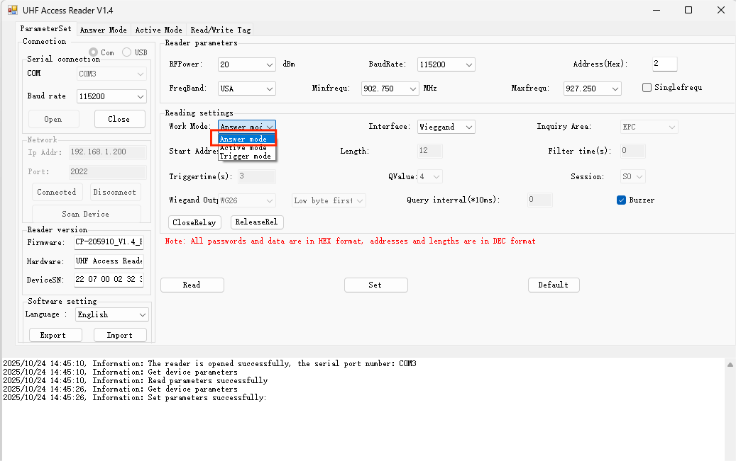

3.2 Read the card by time
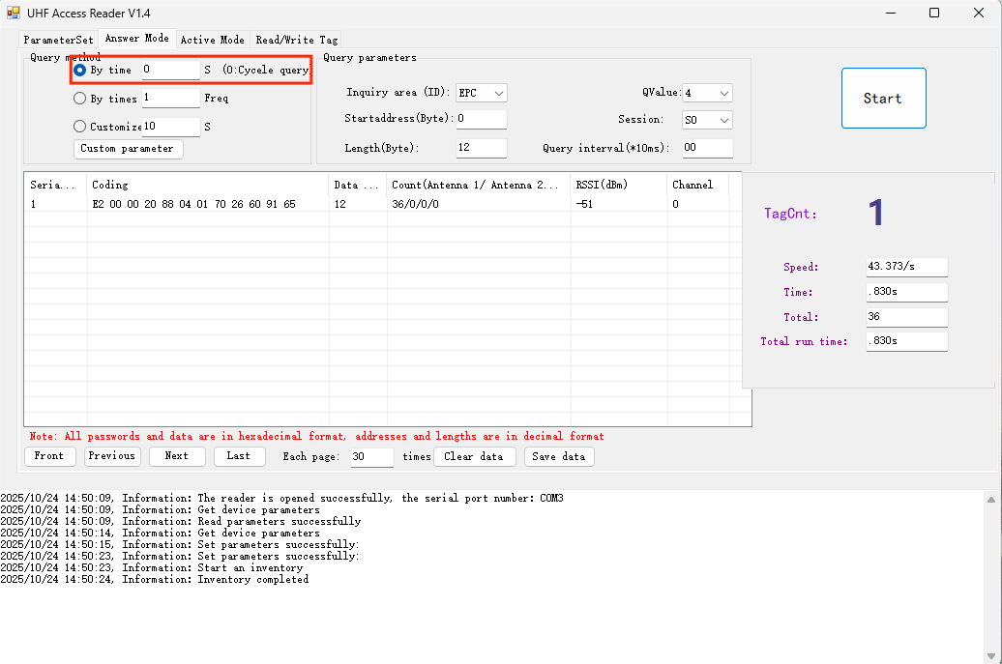
- The card can be read based on time. You can select 0 to 0xFFFF seconds. If you select 0, the counting will continue until you press stop.
- Choose different query parameters for different use cases. When there are many tags, select an appropriate Q value and Session. For details, please refer to 1.3.2 . Section content.
- Choose different output areas and output ranges.
- Reserve, with a default value of 0 to 8 bytes. If the byte length is set to 0, the remaining length of data will be output.
- EPC, with a default value of 0 to 12 bytes. If the byte length is set to 0, the full length of the data will be output.
- TID has a default value of 4 to 12 bytes. If the byte length is set to 0, the remaining length of data will be output.
- User, the default value is 0 ~ 12 bytes. If the length is set to 0, 1 2 bytes of data will be output.

3.3 Read the card by number of times
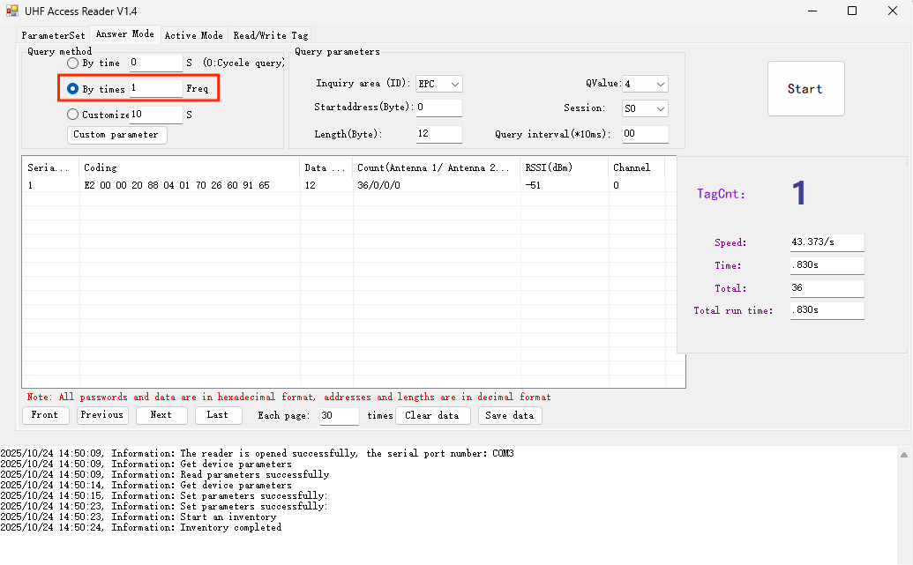

- Inventory checks are performed based on the number of inquiries, applicable to single or multiple inventory counts. The number of inquiries can be selected from 1 to 0 xFFFF.
- Choose different query parameters for different use cases. When there are many tags, select an appropriate Q value and Session. For details, please refer to 1.3.2 . Section content.
- Choose different output areas and output ranges.
- Reserve, with a default value of 0 to 8 bytes. If the byte length is set to 0, the remaining length of data will be output.
- EPC, the default value is 0 ~ 12 bytes. If the byte length is set to 0, the full length of data will be output.
- TID has a default value of 4 to 12 bytes. If the byte length is set to 0, the remaining length of data will be output.
- User, the default value is 0 ~ 12 bytes. If the length is set to 0, 1 2 bytes of data will be output.

4. Active Mode
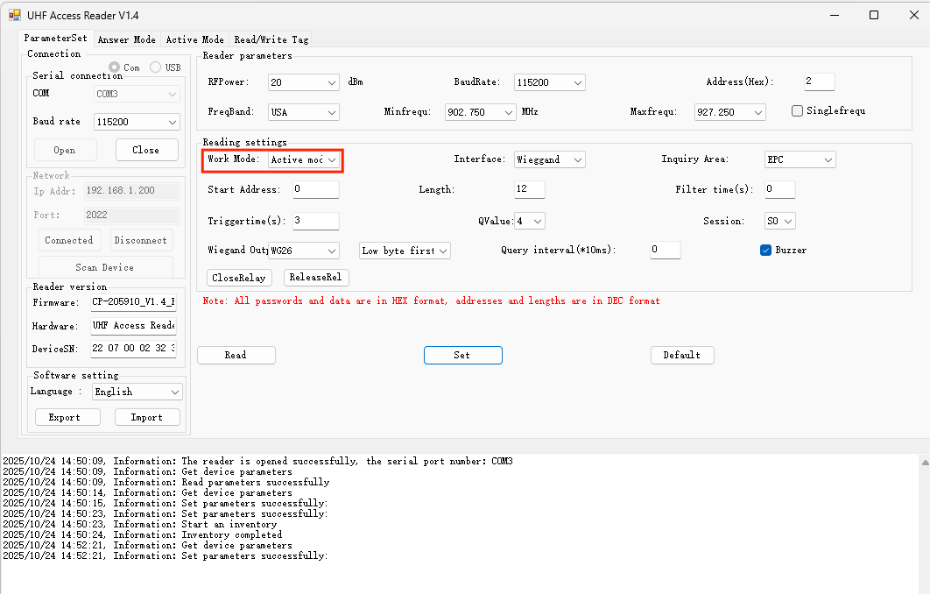
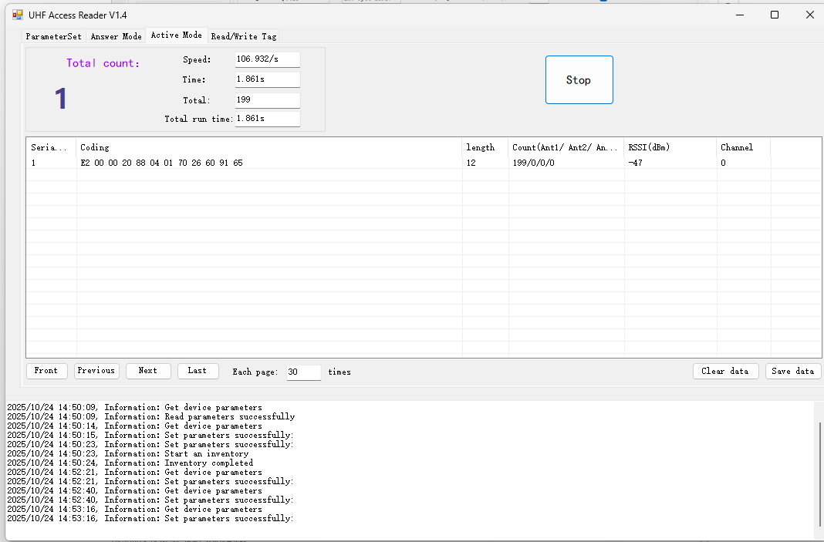
After setting the device to active mode, it will automatically query the device and will not be able to read, write, or lock tags.
Instructions for use:
(1) In the parameter setting interface, select the working mode as active mode and click "Set All Parameters " ;
(2) Set card reader parameters, such as power, antenna, communication interface, query area (number), etc.;
(3) On the active mode interface, click "Get" to view the card number read by the device;
(4) Clear data: Click Stop reading card and then click Clear data;
(5) Save data: Click Stop reading card, then click Save data and select the save location;

5. Trigger Mode
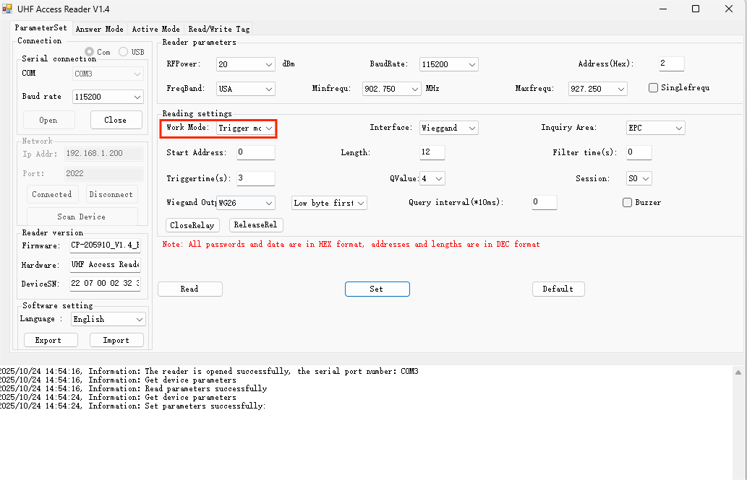
(1) In the parameter setting interface, select the working mode as trigger mode and click "Set All Parameters " ;
(2) Set card reading parameters, such as power, trigger time (3-255), communication interface, query area (number), etc.;

6. Common Mistakes

6.1 Device cannot connect
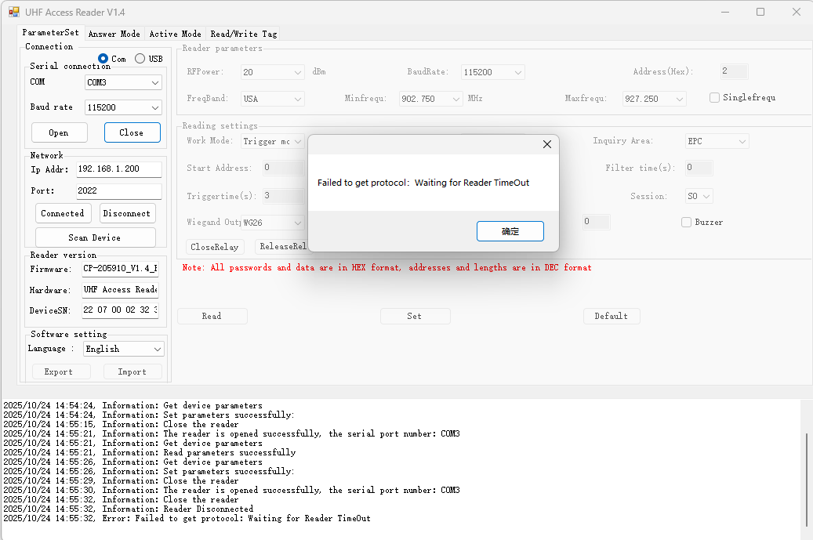
Solution:
- Check if the connected serial port and baud rate are correct;
- Is the equipment powered on normally?

6.2 Parameter out of bounds :

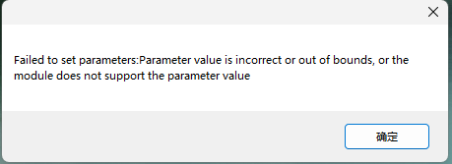
Solution:
Check the configured parameters to see if they are supported. For example, power and antenna settings.

6.3 antenna is not connected .
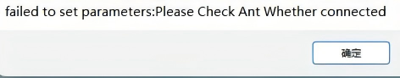
Solution:
Check if the antenna is connected or if the antenna connector is loose.

6.4 The software automatically disconnects .

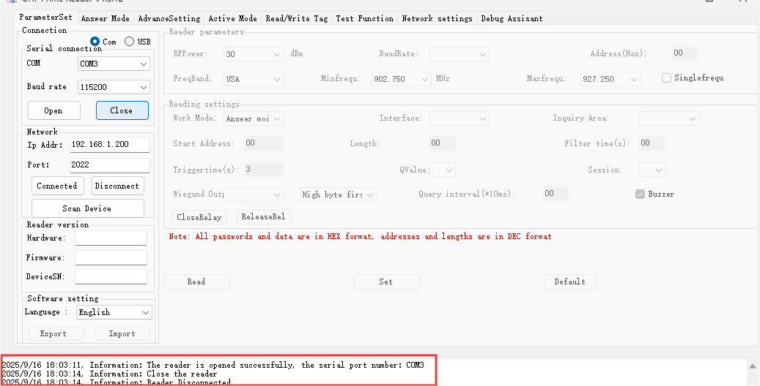

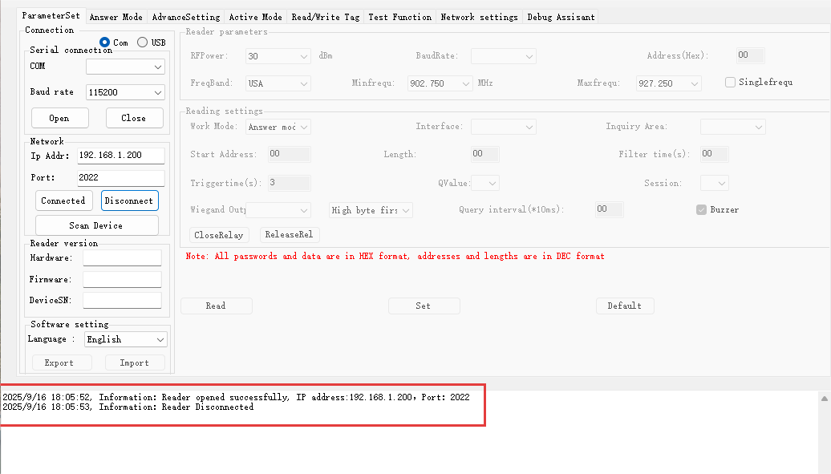

Solution: The correct software is not being used . Consult a salesperson to obtain the correct software .

6.5 reader failed to open.
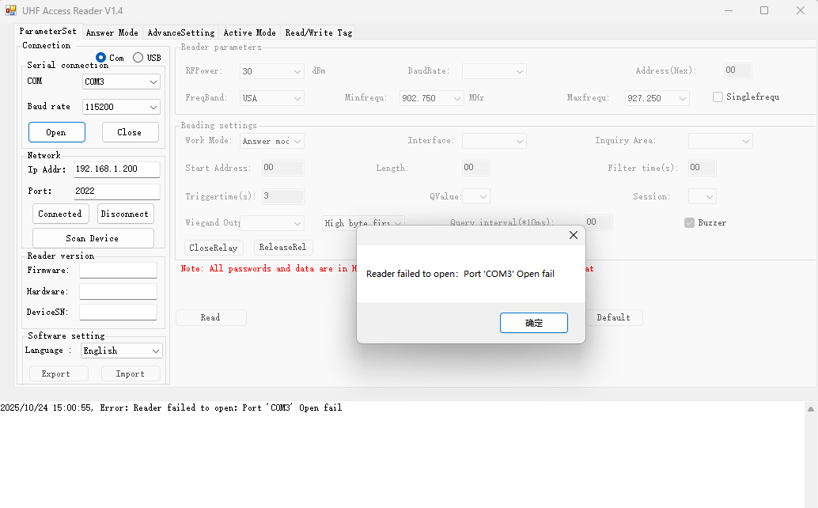
Solution: If the port is in use, please close the software using the port.

